**COMSATS** **University Islamabad, Lahore Campus**

**Department of Electrical Engineering**



**Assignment 3 – Semester Spring 2021**

|  |  |  |  |  |  |  |  |  |
| --- | --- | --- | --- | --- | --- | --- | --- | --- |
| Course Title: | Programing Fundamentals | | | | Course Code: | CSC103 | Credit Hours: | 4(3,1) |
| Course Instructor/s: | Tahir Muhammad | | | | Program Name: | BSE | | |
| Semester: | 1st | Batch: | Sp21 | Section: | C | Date | 6/4/2021 | |
| Student’s Name: | **Muhammad Talha Shafiq choudhary** | | | | Reg. No. | Sp21-BSE-008 | | |
| **Important Instructions / Guidelines:**   * Submission will be on Turnitin and in printed form. * Use front page while submit it in printed form. * Do not copy code from internet else you will be **awarded with a zero**. * Online Submission Deadline **04-06-2021 11:00 PM** | | | | | | | | |

**Q1: FlipDigital**: FlipDigital is a company that manufactures harddisks of various RPM (Revolutions Per Minute) to cater to the needs of all individuals. Usually, the life span of their harddisks is more than 10 years, i.e. It should work for atleast 10 years. Unfortunately, a serious bug was detected, due to which the **RPM increases or decreases every year** in the following manner: (a) multiply the number 323 to sum of the squares of the digits of the RPM,  (b) shift the digits of the RPM to the right by 1 position in a cyclic way, and finally (c) extract the last two digits of the new number obtained and add to the result obtained in 'a'. The final result (c) is the new RPM.

The issue is that if the RPM increases by a certain limit, then the hard disk crashes, which is also dangerous to the person who is using it. **The maximum limit of the RPM of the hard disk is 8 times of the RPM**, i.e. if RPM of harddisk is 1000, then the maximum RPM can be 1000 * 8 = 8000. This issue needs to be resolved before they release the harddisks to the general public. We have been given a contract to find out (based on the RPM) which harddisks will last for more than 10 years, and which will not.

**Assume that the RPM is between 3524 and 8524 only, both inclusive.**

**Task:**  You are required to write code that does the following:-

* 1. Find out the sum of the squares of the digits of the RPM
  2. Multiply the number obtained in (1) by 323
  3. Do a cyclic right shift of digits of the RPM i.e. if Number is 1234, after cyclic right shift, the number will be 4123. Thereafter, take the last two digits of the number obtained just now, and add it to the number obtained in point 2. Thus, obtaining a new RPM value.
  4. Do these steps till the number of years are 10 or the harddisk has reached the maximum RPM

**Example 1**: Assume an **RPM of 5524**. So, the **maximum limit of RPM is 5524 * 8 = 44192**

|  |  |  |  |  |  |  |
| --- | --- | --- | --- | --- | --- | --- |
| **RPM** | **Years** | **SSD** | **A SSD * 323** | **B Cyclic Right Shift** | **A + last 2 digits of B** | **Result (Next RPM)** |
| 5524 | 1 | 42 + 22 + 52 + 52 = 16 + 4 + 25 + 25 | 70 * 323 = 22610 | 4552 | 22610 + 52 | 22662 |
| 22662 | 2 | 22 + 62 + 62 + 22+ 22 = 4 + 36 + 36 + 4 + 4 | 84 * 323 = 27132 | 22266 | 27132 + 66 | 27198 |
| 27198 | 3 | 82+ 92+ 12+ 72 + 22 = 64 + 81 + 1 + 49 + 4 | 199 * 323 = 64277 | 82719 | 64277 + 19 | 64296 |
| **Stop computing further as the maximum limit of RPM is 44192, and the RPM after 3 years is 64296** | | | | | | |

**Example 2**: Assume an **RPM of 7024**. So, the **maximum limit of RPM is 7024 * 8 = 56192**

|  |  |  |  |  |  |  |
| --- | --- | --- | --- | --- | --- | --- |
| **RPM** | **Years** | **SSD** | **A SSD * 323** | **B Cyclic Right Shift** | **A + last 2 digits of B** | **Result (Next RPM)** |
| 7024 | 1 | 42 + 22 + 02 + 72 = 69 | 69 * 323 = 22287 | 4702 | 22287 + 2 | 22289 |
| 22289 | 2 | 92 + 82 + 22 + 22 + 22 = 157 | 157 * 323 = 50711 | 92228 | 50711 + 28 | 50739 |
| 50739 | 3 | 92 + 32 + 72 + 02 + 52 = 164 | 164 * 323 = 52972 | 95073 | 52972 + 73 | 53045 |
| 53045 | 4 | 52 + 42 + 02 + 32 + 52 = 75 | 75 * 323 = 24225 | 55304 | 24225 + 4 | 24229 |
| 24229 | 5 | 92 + 22 + 22 + 42 + 22 = 109 | 109 * 323 = 35207 | 92422 | 35207 + 22 | 35229 |
| 35229 | 6 | 92 + 22 + 22 + 52 + 32 = 123 | 123 * 323 = 39729 | 93522 | 39729 + 22 | 39751 |
| 39751 | 7 | 12 + 52 + 72 + 92 + 32 = 165 | 165 * 323 = 53295 | 13975 | 53295 + 75 | 53370 |
| 53370 | 8 | 02 + 72 + 32 + 32 + 52 = 92 | 92 * 323 = 29716 | 5337 | 29716 + 37 | 29753 |
| 29753 | 9 | 32 + 52 + 72 + 92 + 22 = 168 | 168 * 323 = 54264 | 32975 | 54264 + 75 | 54339 |
| 54339 | 10 | 92 + 32 + 32 + 42 + 52 = 140 | 140 * 323 = 45220 | 95433 | 45220 + 33 | 45253 |
| **Stop computing, as 10 years have passed and still the RPM has not exceeded the maximum limit.** | | | | | | |

**You are required to do the following:**

* 1. Find out the sum of the squares of the digits of the RPM
  2. Multiply the number obtained in (1) by 323
  3. Do a cyclic right shift of digits of the RPM and take the last two digits of the number obtained just now, and add it to the number obtained in point 2. Thus, obtaining a new RPM value.
  4. Do these steps till the number of years are 10 or the harddisk has reached the maximum RPM
  5. Finally assign the modified value i.e. the final of RPM to the variable '**finalRPM**'

**Best of Luck! 😊**

|  |
| --- |
| **Soultion :**  **#include <stdio.h>**  **#include <conio.h>**  **int main()**  **{**  **int RPM = 0, SSD = 0, multiply = 0, number1 = 0, number2 = 0, next_rpm = 0, shift_num= 0;**  **int Maxlimit = 0, loop_RPM = 0, year = 1;**  **int i;**  **printf("--------------------------Enter the RPM of Disk");**  **printf("\n--------------------------Value should be in between 3524 and 8524: ");**    **scanf("%d", &RPM);**  **Maxlimit = RPM * 8;**  **loop_RPM = RPM;**  **while(RPM < Maxlimit && year <= 10)**  **{**  **if(RPM > 999 && RPM < 9999)**  **{**  **number1 = (RPM % 10) * 1000;// 4332 = 2000**  **number2 = (RPM / 10); // 433**  **shift_num = number1 + number2; // = 2433**  **int numbers[4];**  **printf("\nThe Separated digits are: ");**  **for(i = 0; i < 4; i++)**  **{**  **numbers[i] = RPM % 10;**  **SSD = SSD + numbers[i] * numbers[i]; //4 + 9 + 9 + 16 = 38**  **RPM = RPM / 10; // 433 , 43**  **printf("%d ", numbers[i]);**  **}**  **printf("\nYear no # %d\n", year);**  **multiply = SSD * 323; // 12274**  **next_rpm = multiply + (shift_num % 100); // 12274 + 32**  **printf("Value of SSD is : %d\n", SSD);**  **printf("SSD * 323 gives : %d\n", multiply);**  **printf("Value of RPM after cyclic right shift : %d\n", shift_num);**  **printf("Next RPM value : %d\n", next_rpm);**  **printf("\n===================================================\n\n");**  **year++;**  **RPM = next_rpm;**  **}**  **if(RPM > 9999 && RPM < 99999)**  **{**  **number1 = (RPM % 10) * 10000;**  **number2 = (RPM / 10);**  **shift_num = number1 + number2;**  **int number[5];**  **SSD = 0;**  **multiply = 0;**  **printf("The Separated digits are: ");**  **for(i = 0; i < 5; i++)**  **{**  **number[i] = RPM % 10;**  **SSD = SSD + number[i] * number[i];**  **RPM = RPM / 10;**  **printf("%d ", number[i]);**  **}**  **printf("\nYear no # %d\n", year);**  **multiply = SSD * 323;**  **next_rpm = multiply + (shift_num % 100);**  **printf("Value of SSD is : %d\n", SSD);**  **printf("SSD * 323 gives : %d\n", multiply);**  **printf("Value of RPM after cyclic right shift : %d\n", shift_num);**  **printf("Next RPM value : %d\n", next_rpm);**  **printf("\n=================================================\n\n");**  **year++;**  **RPM = next_rpm;**  **}**  **if(RPM > 99999 && RPM < 999999)**  **{**  **number1 = (RPM % 10) * 100000;**  **number2 = (RPM / 10);**  **shift_num = number1 + number2;**  **int number[6];**  **SSD = 0;**  **multiply = 0;**  **printf("The Separated digits are: ");**  **for(i = 0; i < 6; i++)**  **{**  **number[i] = RPM % 10;**  **SSD = SSD + number[i] * number[i];**  **RPM = RPM / 10;**  **printf("%d ", number[i]);**  **}**  **printf("Year no # %d\n", year);**  **multiply = SSD * 323;**  **next_rpm = multiply + (shift_num % 100);**  **printf("Value of SSD is : %d\n", SSD);**  **printf("SSD * 323 gives : %d\n", multiply);**  **printf("Value of RPM after cyclic right shift : %d\n", shift_num);**  **printf("Next RPM value : %d\n", next_rpm);**  **printf("\n==================================================\n\n");**  **year++;**  **RPM = next_rpm;**  **}**  **}**  **return 0;**  **}** |

**Example 1**: Assume an **RPM of 5524**. So, the **maximum limit of RPM is 5524 * 8 = 44192**

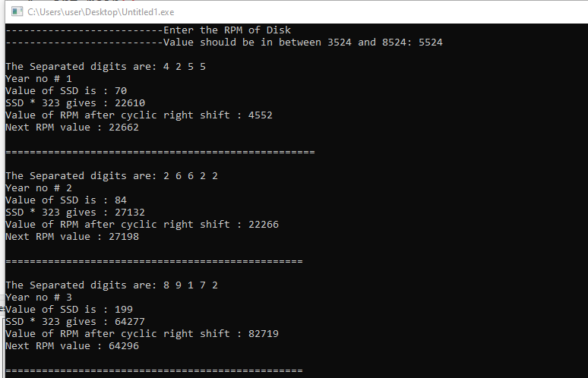

**Example 2**: Assume an **RPM of 7024**. So, the **maximum limit of RPM is 7024 * 8 = 56192**

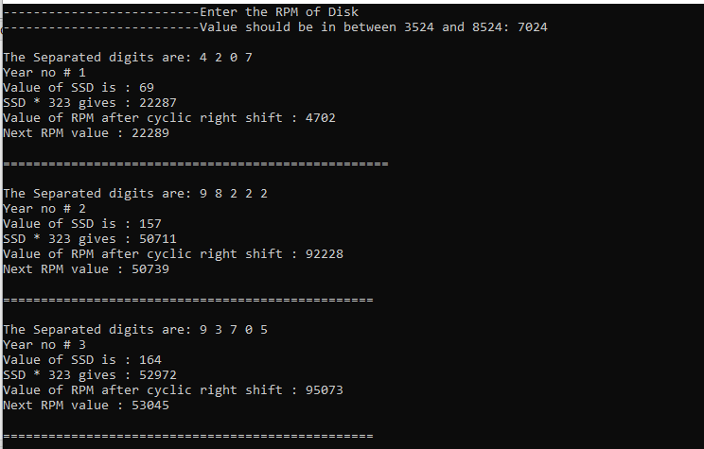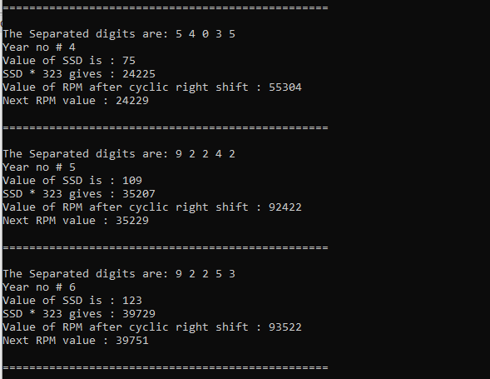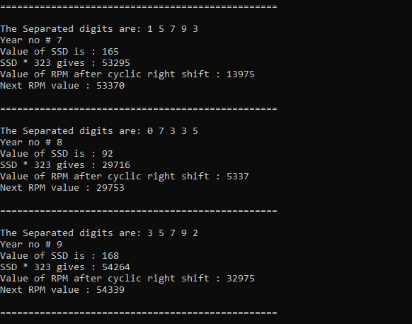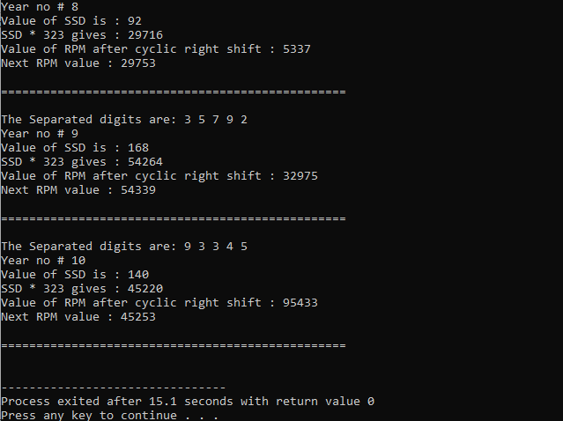

#include <stdio.h>

#include<stdlib.h>

#include<math.h>

int main()

{

int rpm,finalrpm,maxrpm;

int temp=0,temp1=0;

int rem=0,rem1=0;

int count=0,k=0;

int year=1;

int shift=0;

printf("\nENTER THE <RPM> OF HARDDISK.VALUE SHOULD BE BETWEEN 3524 and 8524.\n");

scanf("%d",&rpm);

if(rpm<3524 || rpm>8524)

{

printf("\n INVALID RPM");

printf("\n Value should be inbetween 3524 and 8524.\n");

}

else

{

maxrpm = rpm * 8;

printf("\nThe maximum limit of the RPM is %d\n",maxrpm);

printf("\n");

while(year<11)

{

int sum=0;

count = 0;

temp=rpm;

temp1=rpm;

while(temp!=0)

{

rem=(temp%10)*(temp%10);

sum=sum+rem;

temp=temp/10;

count++;

}

rem1=temp1%10;

temp1=temp1/10;

shift=rem1*pow(10,count-1) + temp1;

shift=shift%100;

finalrpm=shift+(sum*323);

printf("\n YEAR\t|RPM\t|SUM OF SAQUARE\t|SAQUARE*323\t|RIGHT SHIFT ELEMENT\t|FINAL RPM");

printf("\n");

printf("\n %d\t %d\t\t%d\t %d\t\t\t%d\t\t %d",year,rpm,sum,sum*323,shift,finalrpm);

printf("\n");

printf("\n------------------------------------------------------------------------------");

printf("\n");

if(finalrpm>maxrpm)

break;

else

rpm=finalrpm;

year++;

}

}

}